Chapter 15 Vocab. Edwardian & WWI

1. Ascot - Alex Clark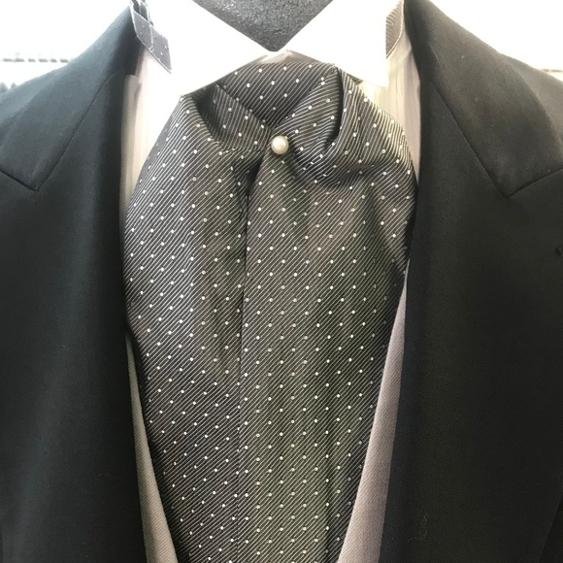

The ascot was a tie that had wide ends that were worn with an end looped over the other then held in place with a pin. Traditionally the ascot was made out of a gray patterned silk. The tie got its name from the racetrack Ascot Heath and became popularized by the spectators at the track.

Sources

Survey of Historic Costume, Page 438

<https://www.encyclopedia.com/fashion/encyclopedias-almanacs-transcripts-and-maps/ascots>

<https://en.wikipedia.org/wiki/Ascot_tie>

<https://poshmark.com/listing/Vintage-Pin-Dot-Ascot-5d8e95f5151ccd46fea9c343>

1. Blazer: Abbie Burns

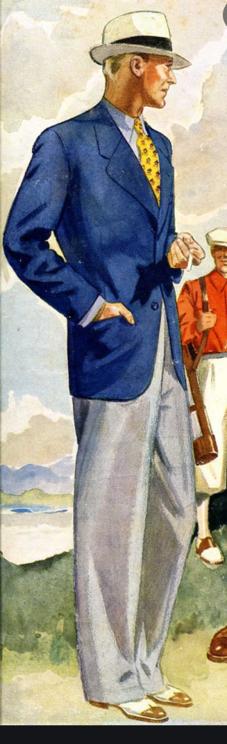

This is compared to today's sports jacket. A blazer is paired with an unmatched trouser. People wore them for sporting events including tennis and yachting. This jacket came to life after Queen Victoria oversaw the crew of HMS Blazer, who was the captain and had no uniform for his men. But when they went to honor the queen in a parade they were wearing dark blue jackets with gold buttons and the queen gave them their names “blazer”. Today there are two types of blazes, single and double breasted. Traditionally blazers have gold buttons “navel style” and tend to be a more formal attire.

Source:

Book 440

https://en.wikipedia.org/wiki/Blazer

https://www.josephturner.co.uk/customer/pages/about/mens-blazer-styles

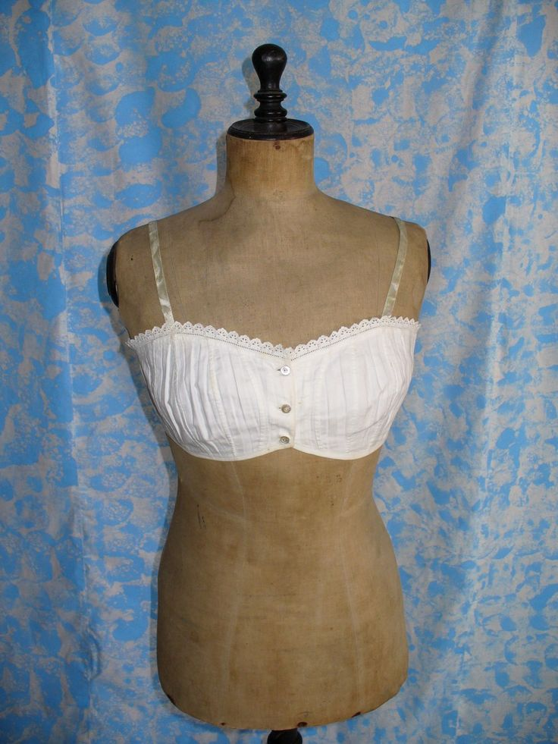

1. Brassiere- Hailey Child

Brassieres became widely available during this time. They would be worn with a corset to keep the form nice and neat. The inside layer of the brassiere has a corset shape that laces in the front. Typically made of cotton these brassieres were worn to give an “S-bend” or pigeon-breasted silhouette.

<https://www.sewhistorically.com/dressing-the-1900s-woman-edwardian-lingerie/>

Book

<https://thefashionarchaeologist.com/blog/what-went-where-edwardian-lingerie-and-how-to-wear-it>

1. Delphos Gown- Samantha Hooper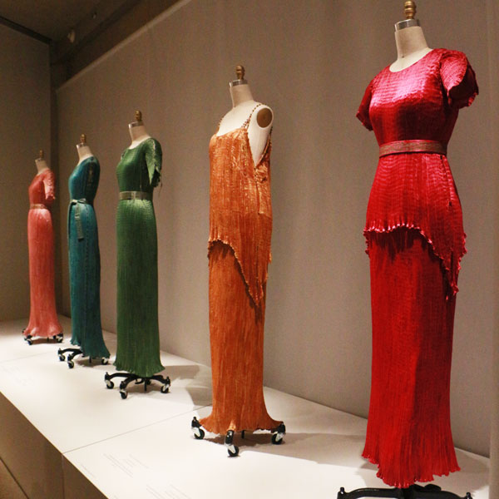

The Delphos gown was first designed by Spanish designer Mariano Fortuny, along with his wife Henriette in 1907. It became Fortuny’s signature gown, a column dress that is inspired by the Greek Chiton. The gowns were made from a finely pleated silk and with many different necklines and sleeves over the forty years that they were in production. The dress was worn without a corset so that the female body could move freely in it, inspired by the Modernism movement and the Aesthetic movement of the previous era.

1. Duster - Debbi Wright

Our textbook tells us that the drivers of automobiles no longer had to worry about what to wear. They would wear a “duster”. This was a sort of overcoat that was worn to protect the clothing from dust and such because the cars at the time were open and the roads were unpaved. The dusters were usually made in shades of tan and were either cotton or linen.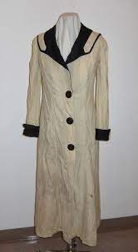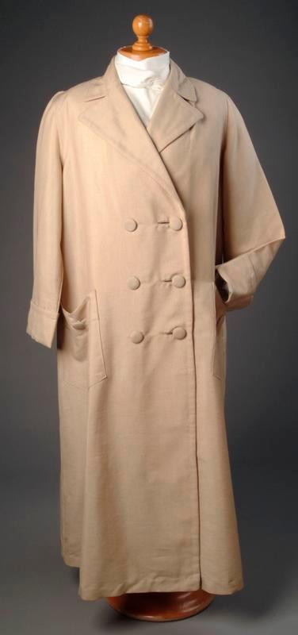

Toratora, Phyllis G, and Keith Eubank. Survey of Historic Costume, 5th Edition. Berg, 2009

<https://emuseum.aberdeencity.gov.uk/objects/22760/cream-duster-coat>

<https://www.wimuseum.org/lets-go-for-a-drive-the-motoring-duster/>

1. Eton Suits : Elizabeth Nathan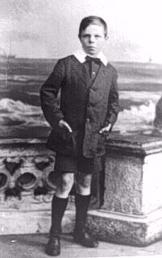

It was in England that the Eton suit was created in the late 19th century and it was in England that the Eton suit reached its greatest popularity. For two generations a well dressed English boy was expected to wear an Eton suit for formal occasions. Many boys also wore them as a school uniform. Many boys also wore Eton collars with a range of suits. Only suits with short jackets are true eton suits. The characteristically short jackets are normally worn with long pants. We see boys wearing Eton collars with a variety of pants, but often they are not true Eton suits.

<https://histclo.com/style/suit/eton/etonsn-eng.html>

<https://histclo.com/style/suit/eton/etons.html>

1. Four-in-hand
2. Haute Couture - Marisa Bone

Haute Couture is the fusion of both fashion and costume. It brings the art of garment making to the practicality of garment wear. In the earlier years of the 20th century Paul Poiret carried on Charles Worth's legacy and couture came to life once again in the postwar period. There is even the saying that Poiret is the “inventor” of the runway. This began with Christian Dior's "New Look." in 1947. As a mixture of design and technique, it remains a force in fashion today. 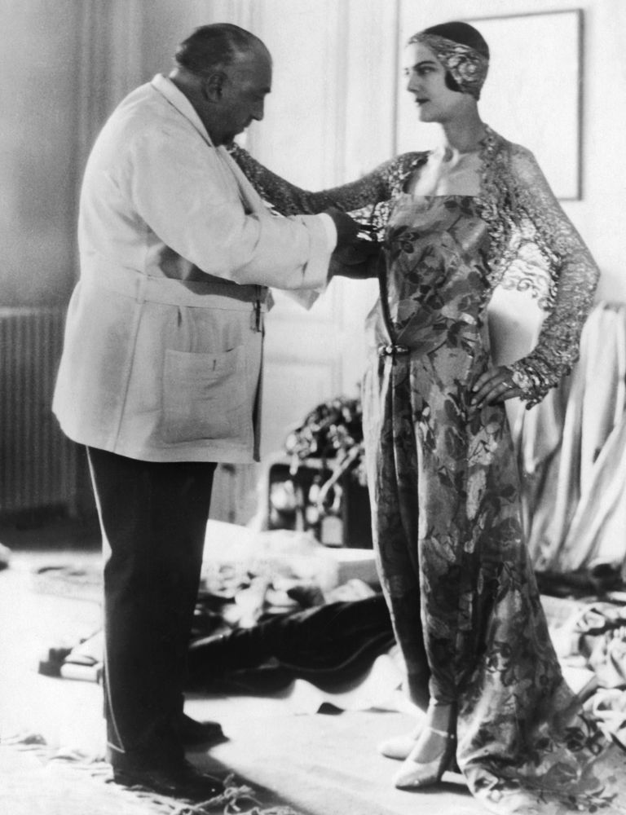

[Source 1](https://www.metmuseum.org/toah/hd/haut/hd_haut.htm?utm_source=Twitter&utm_medium=tweet&utm_content=20140926&utm_campaign=toah) [Source 2](https://www.crfashionbook.com/fashion/a32210792/paul-poiret-fashion-history/) Page 427

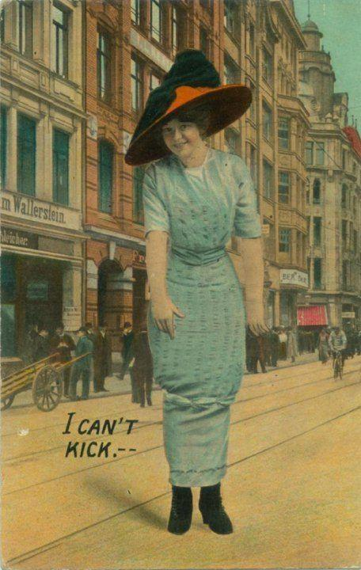

1. Hobble skirt - Amanda Taylor

This skirt trend became popular between 1910 and 1913. These skirts were very slim which forced women to take tiny steps which was very restricting. The name hobble skirt came because women had to kind of hobble when they walked in one. This skirt was said to be unsafe and some women were not allowed to wear them in their workplace because they weren’t safe. Around 1913 the hobble skirts started to be made with concealed slits or hidden pleats to make them more practical.

<https://www.edwardianpromenade.com/beauty/the-hobble-skirt/>

Textbook 390

<https://en.wikipedia.org/wiki/Hobble_skirt>

1. Jodhpur - Jalissa Cloward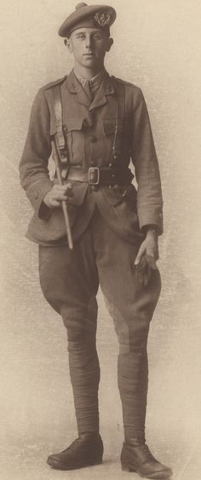

The jodhpur is a pair of trousers that were made for active wear. They flare out at the top, but are closely fitted around the lower leg. The jodhpur originated in India where Sir Pratap Singh was unhappy with the clothes he wore for polo, so he came up with a pair of pants that suited the needs of the game. The style was later adopted by England and spread. The jodhpur was mainly used in sports, but was also adopted for uniforms.

Survey of Historic Costume pg. 440

<https://www.equus.co.uk/blogs/community/15158909-the-history-of-riding-jodhpurs>

<https://www.gentlemansgazette.com/jodhpurs-guide-pants-history-style-where-to-buy/>

1. Juliet cap- Jessica Fraser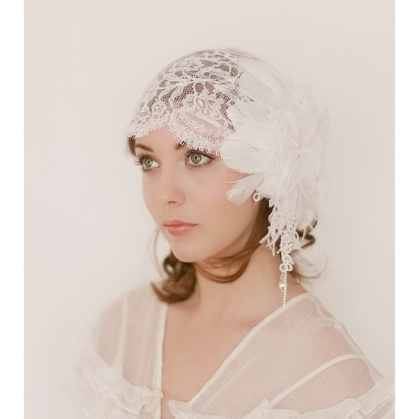

The Juliet Cap originated from France in the 16th century. They were used as wedding veils and had jewels, lace, feathers, beads, and all sorts of beautiful arrangements. They also were pretty small, just to fit on the top of the head. It was round and fir very closely. It could be crochet or made of mesh. A bridal cap.

The Book

<https://vintagefashionguild.org/hat-resource/juliet-cap-calot/#:~:text=The%20calot%20(French%20for%20cap,and%20were%20usually%20lavishly%20embellished>.

<https://en.wikipedia.org/wiki/Juliet_cap>

1. Knickers (undergarment)
2. Lingerie dress - Irelynd Preece

The Lingerie dress was a popular white, frilly cotton or linen dress with decorations that included tucking, pleating, lace insertions, bands of applied fabric, lace, and embroidery. It was said that these dresses were labeled “Lingerie dresses” due to the fabric and decoration so closely resembling womens undergarments or lingerie of this time period. Something that is interesting about the Lingerie dress is that due to the gradual change in fashionable body and dress during this time period the proportions, waistline, hemline, and sleeves of the Lingerie dress were transformed to reflect the change in taste. The Lingerie dress was designed after the chemise gown. 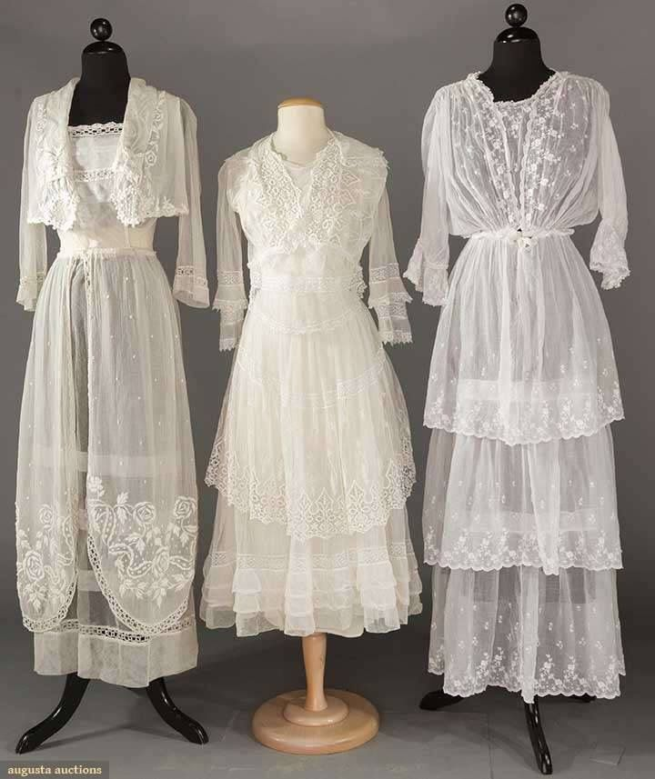

Textbook page 425 & 427

<https://pinsndls.com/2012/01/21/1900-1910-the-reign-of-the-lingerie-dress/>

<https://en.wikipedia.org/wiki/Lingerie_dress>

1. Lounge coat- Abigail Storrer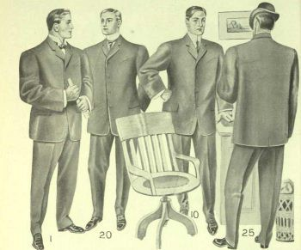

The lounge coat was the word that the British used in reference to what Americans called a sack jacket. Though the sack jacket came about a few decades earlier halfway through the 19th century, they stayed around and in the 20th century became the standard suit jacket and were worn all the time. The coats had no waistline and were straightforwardly simple. They had no cuffs either. This jacket varied a little with the decades but stayed relatively the same. This jacket made an appearance in more relaxed settings, business settings, and even in sports.

Survey of Historic Costume, Pg. 370 &437

<http://www.fashionencyclopedia.com/fashion_costume_culture/Modern-World-1900-1918/Sack-Suit.html>

<http://www.historyinthemaking.org/1885-1910.html>

1. Mackintoshes- Ida Johnson

Name given to rainwear, invented and named for Charles Mackintosh. The fabric used for a mackintosh was made waterproof by cementing two thicknesses of it together with rubber dissolved in a coal-tar naphtha solution. Waterproof, especially applicable to overcoats. 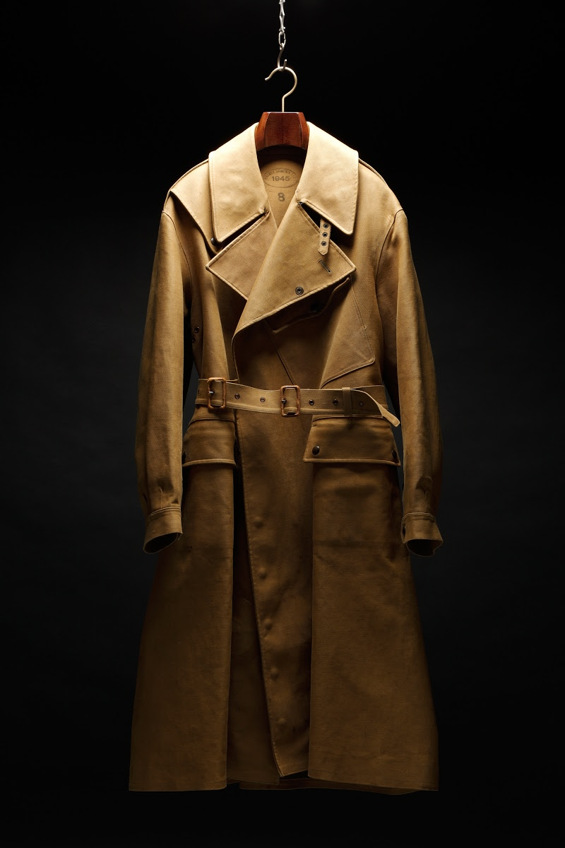

<https://www.britannica.com/topic/mackintosh>

<https://www.mackintosh.com/us/brand-story>

1. Minaret tunic- lena Kawakami- 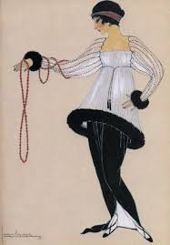

this style of tunic was originally designed by Paul poiret, he also invented the hobble skirt and Paul is sometimes referred to as a king of fashion, he took a different approach to clothing and worked with fabric directly on the body and used a lot of draping rather then make patterns and tailor. You would typically wear a minaret tunic over a hobble skirt. This tunic was also referred to as the lampshade tunic. It has bones to hold out the skirt part in a full circle. Paul designed with an artistic approach which made him original and unique <https://witness2fashion.wordpress.com/tag/poiret-minaret-tunic-1924-1920s/> <https://www.metmuseum.org/exhibitions/listings/2007/poiret>

1. Pajamas - Kya Boyd 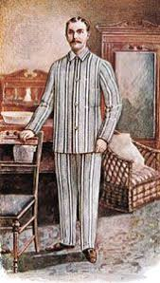

Also spelled pyjamas are lightweight loose trousers with a loose silk or cotton shirt for lounging. This started in the East and was introduced to England as lounging attire in the 17th century, but was a fad until it returned back to the western world as sleepwear for men. It wasn’t until the beginning of the 20th century, pajamas were introduced as women's sleepwear. It was more popular for women to wear night gowns, but as time went on pajamas became a unisex wear and liberation for females as they are breaking away from the sexualized behaviors in fashion before.

Sources:

<https://www.britannica.com/topic/pajamas>

<https://www.gilis.com/en/logbook/102-the-history-and-origin-of-pajamas>

“Survey of Historic Costume”

1. Peg-top skirt-Brittany Pocock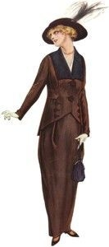

It was a skirt that was tighter at the hem but wider at the top creating a loose blousy effect. It helped create the shape that was really desired. Because they were tight at the bottom it made the wearer walk in tiny steps. Sometimes a slit is put in the bottom to help them walk better.

Book

[Hobble Skirts - Fashion, Costume, and Culture: Clothing, Headwear, Body Decorations, and Footwear through the Ages (fashionencyclopedia.com)](http://www.fashionencyclopedia.com/fashion_costume_culture/Modern-World-1900-1918/Hobble-Skirts.html#:~:text=Like%20the%20hobble%20skirt%2C%20the%20peg%20skirt%20was,westerners%20imagined%20women%20might%20walk%20in%20the%20East.)

[65 Different Skirt Styles (Mega Skirt Chart) - ThreadCurve](https://threadcurve.com/types-of-skirts/)

1. Picture hat-Marisol Dejesus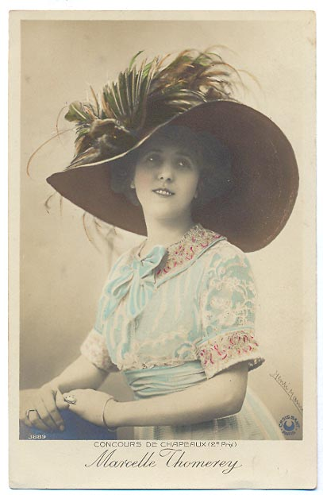

Picture hats are large-brimmed, usually trimmed. It can be decorated with artificial flowers, lace, buckles, bird wings, and feathers. The first term was used in 1887 in NZ newspapers. Picture hats had different names like Gainsborough Chapeau or garden hats. It became popular in the early 1890s then remained until the 1910s.

Textbook pg:428

<https://thedreamstress.com/2011/12/terminology-what-is-a-picture-hat/#:~:text=A%20picture%20hat%20is%20a,hat%2C%20usually%20rather%20elaborately%20trimmed>.

<https://en.wikipedia.org/wiki/Picture_hat>

1. Pompadour -Savannah Tanner

The pompadour was a hairstyle that had the hair styled in a manner that was high in the front and around the face and rolled up high over the forehead. The style was introduced by Madame de Pompadour, a mistress of King Louis XV. The hairstyle was revamped in the 1890’s by the Gibson Girls. Variations of this style can still be seen today.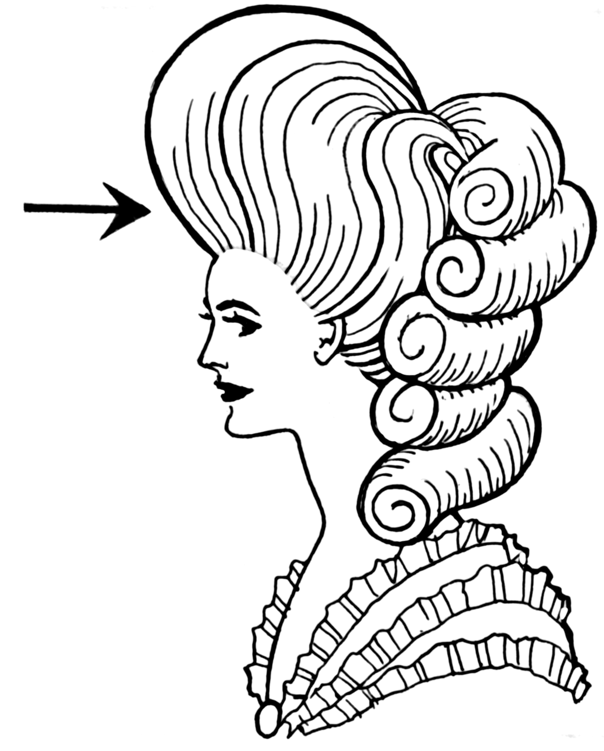

Pg. 428

<https://www.britannica.com/topic/pompadour>

<https://www.nwcollege.edu/blog/article/the-history-of-the-pompadour>

1. Princess Petticoat- Jamie Rakes

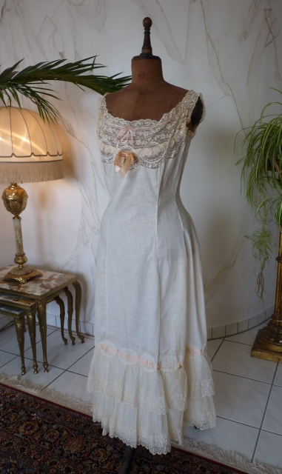

The princess petticoat was oftentimes accompanied by a corset to make a seemingless smooth front silhouette that then on the back was accompanied by extra layers and gathers on the back of the petticoat to add more dimension. It also wasn’t intended for this to make a bustle-like appearance but to more just add shape to the figure. The petticoat was the third layer of undergarments that were worn and was worn on top of the corset. The princess petticoat was vital in Edwardian style as it is what helped give the dress its shape. It was important for the petticoat to be free of wrinkles in order to have it give a clean not poofy look to the dress and to have it lay smoothly over the body.

<https://thefashionarchaeologist.com/blog/what-went-where-edwardian-lingerie-and-how-to-wear-it>

<https://ameliaseamstress.wordpress.com/2018/09/26/making-a-1912-princess-slip-and-final-titanic-pictures/>

Textbook pg 330

1. Trench coat - Savannah Jeppson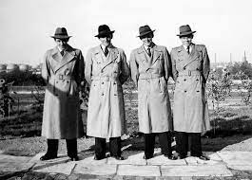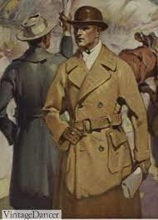

Trench coats became very popular for civilian use after WWI. They were invented by Thomas Burberry during the war and were made of a belted twill cotton gabardine. It had a chemical finish that made the coat water repellent.

Survey of Historical Costume

<https://www.smithsonianmag.com/history/trench-coat-made-its-mark-world-war-i-180955397/>

<https://vintagedancer.com/1920s/1920s-mens-coats-jackets/>

1. Pullover - Kimberly Tesam Moita

The pullover is something we still have today, and back then it was a sweater. In Britain, a sweater may also be called a pullover, jumper, or jersey. (Wikipedia) Men wore them after WW1 due to soldiers being used to wearing the comfortable garments that were issued to them during their time as soldiers, as well as wool being in short supply during the war. After the war, army surplus stores sold the clothing to the general public, and they had success in selling them, adding to their popularity among the public. Sweaters were also worn generally by working class men and included collarless cardigans and high collared styles similar to the modern turtleneck. The image I found is of a pullover worn during baseball in 1907.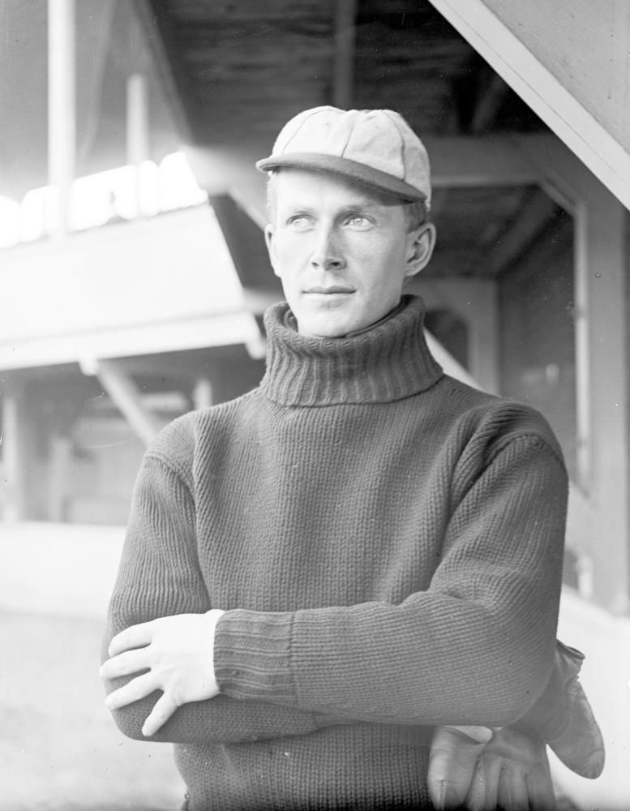

<https://www.familysearch.org/en/blog/1900s-fashion-edwardian-era>

<https://en.wikipedia.org/wiki/Sweater>

<https://www.nytimes.com/1964/10/26/archives/the-history-of-the-sweater-and-where-does-it-go-next-fashions-in.html>

1. Sport jacket - Jensen Stenquist

Sack jackets became the standard suit jacket for men during the 20th century. They were worn for all occasions, and even appeared for leisure time wear. The rich had closets full of suits of every style, color, and material, while the working poor may have had only one good suit to wear to church on Sunday and mismatched suit pieces to wear during the week. Early 1920s men’s suits were made of tweed, mohair, wool, or corduroy. It was very thick material.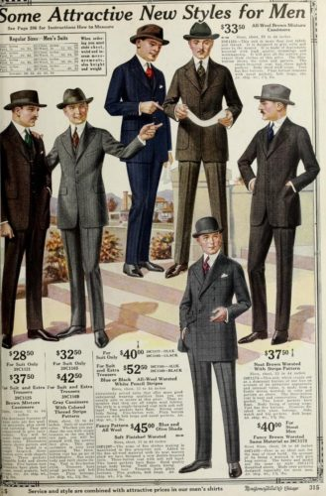

<https://vintagedancer.com/1920s/1920s-mens-fashion-the-suit/>

<https://vintagedancer.com/1900s/1919-clothing/>

Textbook, Pg. 437

1. Stetson (hat)-Anna Ament

Stetson Hat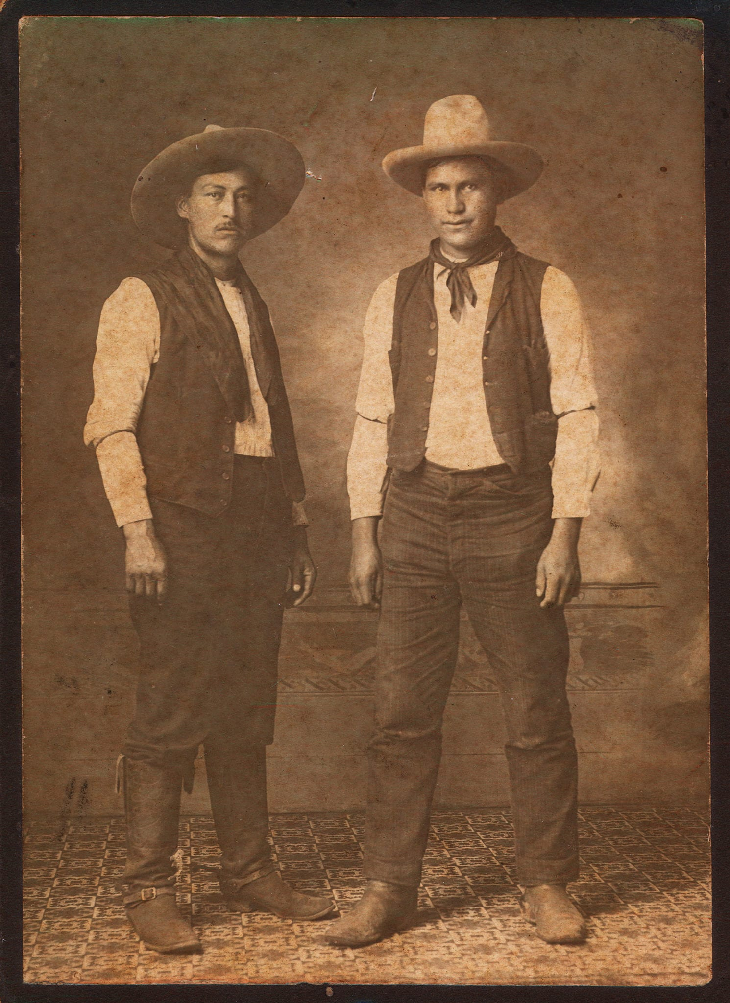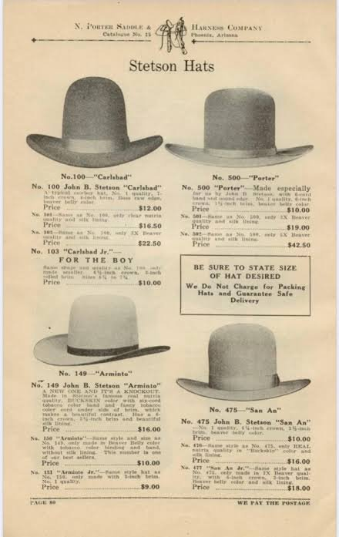

The Stetson Hat was the original inspiration for the cowboy hat that we know and love today. It was made by the John B. Stetson company. The hats were originally made of fur or felt and had straight edges around the brim. The hats were also taller than we normally see them today. Over time as these hats influenced Western wear, they became very common among cowboys especially found in the West. As westerners used these hats for work they became more tattered and worn. Eventually, the hats began to curl up from wear. This became a staple of the iconic cowboy hat.

<https://www.pennersinc.com/pages/the-history-of-stetson-hats>

<https://www.filson.com/blog/field-notes/history-of-cowboy-hat/>

1. Straw boater - Bailey Pinder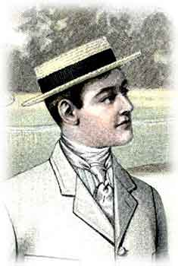

This style of men’s hat was popular in the decade before this one and the decade after it At first this hat was designated to summer holidays or summer sports; but soon it was the favorite warm weather city hat for both upper and middle class men. In general, the boater was made of sennit or split braid straw with a straight narrow brim and finished with fine silk trimmings and a calf-leather sweatband. The ribboned hat band was most often seen in stripes. The straw boater hat is the most common and the most traditional style of boater hat.

<http://www.victoriana.com/Mens-Clothing/strawboater.html>

<https://threadcurve.com/what-is-a-boater-hat/>

Survey of Historic Costume

1. Swiss belt - Jocelyn Munoz

This is a picture of a woman wearing a corselet skirt which took inspiration from the swiss belt.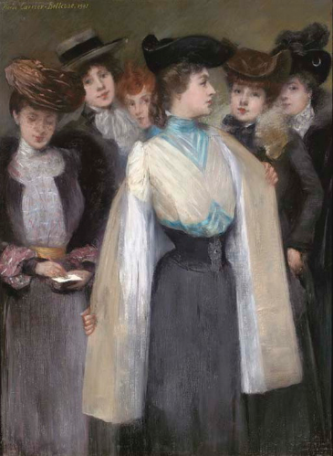

The Swiss belt originally gained popularity in the 1860s but made a revival in the 1900s, they were originally just wide belts with a triangular piece on the front. Though they became thinner and might have had more accessories.

My first link is a picture of two women wearing swiss belts from 1888

<https://digitalcollections.nypl.org/items/510d47e1-1eaa-a3d9-e040-e00a18064a99>

https://thedreamstress.com/2012/07/swiss-waist-waist-cincher-corset-and-corselet-whats-the-difference/

Tortora, P. G., & Marcketti, S. B. (2021). In Survey of historic costume. essay, Fairchild Books.

1. Top coat: Lexie Pincock

Ended at the hip. Seen as someone who had wealth and could afford more than one overcoat. Meant to be worn as an extra layer for the outdoors or colder temperatures.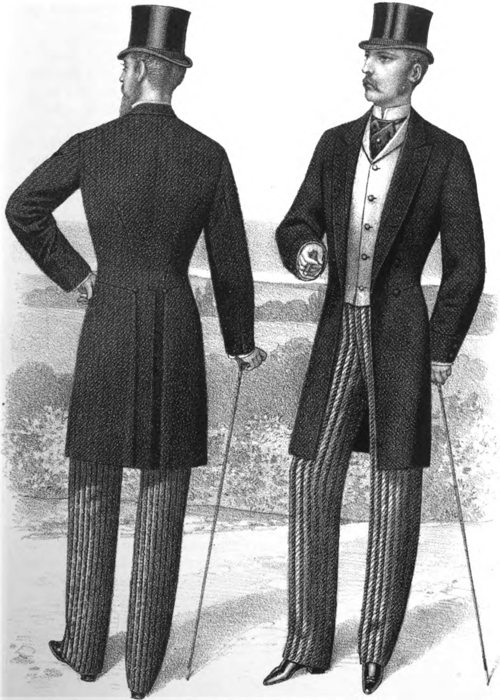

Sources:

Pg. 439-440

<https://www.gentlemansgazette.com/evolution-of-menswear-suits/>

<https://www.gentlemansgazette.com/how-to-buy-an-overcoat/>

1. Trilby hat-z

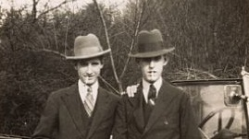

The trilby was a hat similar to a fedora. It had a narrow brim that angled down at the front & turned up at the back. It was made from rabbit fur felt. The name comes from the stage play in London called Trilby. The main heroine was named Trilby & wore this type of hat.

Sources:

Survey of Historic Costume

<https://tailoreddetails.com/en/history-of-the-trilby-hat/>

<https://en.wikipedia.org/wiki/Trilby#:~:text=The%20hat's%20name%20derives%20from,somewhat%20resembles%20the%20Tyrolean%20hat.>

1. ‘S’ Curve silhouette - Aubrey Reidhead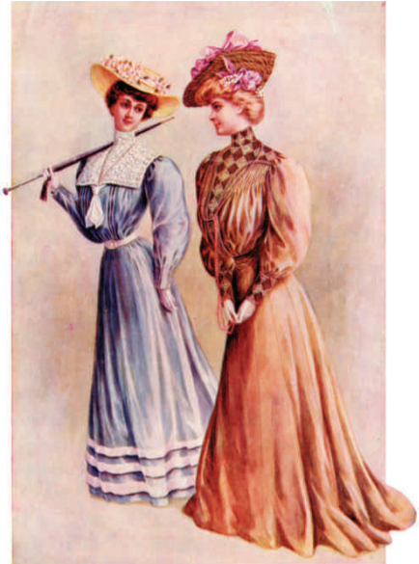

In the book an S-Shaped silhouette was shaped “with a full, pouched bosom and a rounded hipline (pg. 432).” This basically meant that the torso would be forward, and the hips would be pushed and emphasized and formed in the back to jut out significantly to give the women a site profile that resembled that of an S; hence an “S-Shaped” silhouette. The overall silhouette came from a straight fronted corset that was flat in the front and low on the bustline and pushed the hips back([The Met](https://www.metmuseum.org/toah/hd/20sil/hd_20sil.htm)), but sometimes women would use bust improvers or padded corset covers to better achieve the look they desired ([FIDM Museum](https://fidmmuseum.org/2010/10/s-bend-silhouette.html)).

Survey Of Historic Costume 6th Edition

1. Edwardian Colors and Textiles
2. Explain “Edwardian Period”
3. Explain “Gilded Age”
4. Paul Poiret- Andrea Lazaro

Paul Poiret was a fashion designer, known as “the king of fashion” for his innovations in woman clothing during the 1910s. He was the first one to get rid of corsets and introduced the brassiere. His clothes were well-known because of their vivid colors and innovative shapes. He started as a fashion designer for the House of Worth, which made high couture. Poiret later opened his own store to the general public. After World War I, Poiret’s work became less popular until he was left out of business.

Survey of Historic Costume pages 419 &420

<https://www.metmuseum.org/toah/hd/poir/hd_poir.htm>

<https://biography.yourdictionary.com/paul-poiret>

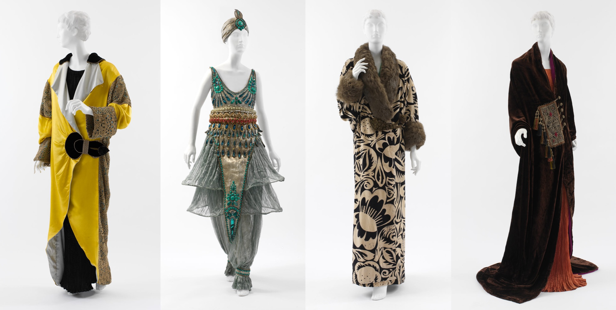

1. Mariano Fortuny - Abby Fluckiger

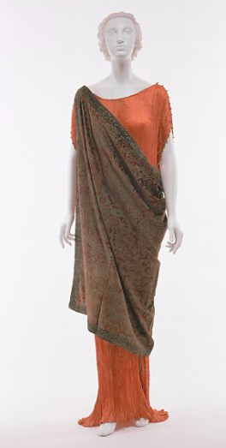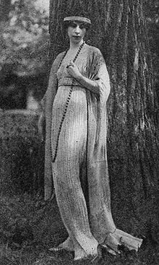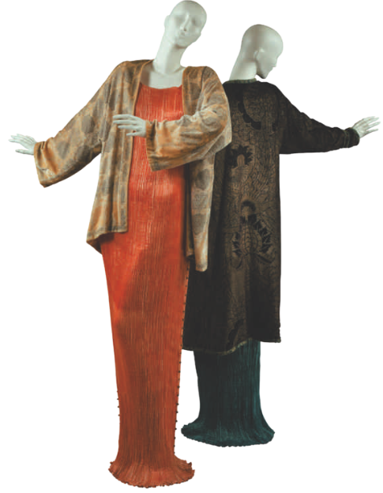

Mariano Fortuny was a Spanish designer and artist who operated from 1906 to 1949. His designs never entered mainstream fashion, as they were intended more as works of art than as strictly fashion; his designs tended towards the streamlined, structureless, and flowing as opposed to the popular structure of the time. His designs were inspired by ancient Greek and Renaissance styles and used fine pleating; one of his most popular designs was the Delphos gown, a pleated sheath dress.

Sources:

Textbook page 427

<https://en.wikipedia.org/wiki/Mariano_Fortuny_(designer)>

<https://www.metmuseum.org/art/collection/search/83312>

1. Suffragettes- Lauren Shumway

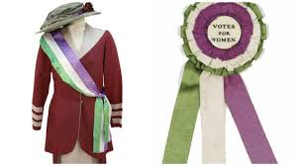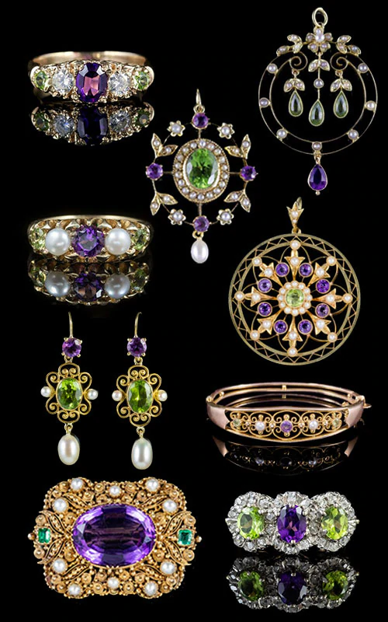

The suffrage movement was a woman-driven movement that demanded women to have the right to vote, equal pay, and equality in the sight of the law. The campaign started to gather support in the 1840s and would last until 1920, when the 19th amendment was passed in the U.S. and 1928 in the U.K.

The Suffragettes is the term for women that belong to the movement. In the senses of fashion, the Suffragettes would use the colors of the movement the purple, white, and green in jewelry, but the most prominent part of the movement’s fashion was the purple, white, and green sash and cockade pins; the movement also made popular red lipstick in 1912.

[https://en.wikipedia.org/wiki/Suffragette#:~:text=](https://en.wikipedia.org/wiki/Suffragette#:~:text=A%20suffragette%20was%20a%20member,to%20vote%20in%20public%20elections)

<https://en.wikipedia.org/wiki/Women%27s_suffrage_in_the_United_States>

[https://www.theguardian.com/fashion/2015/oct/08/suffragette-style-movement-embraced-fashi](https://www.theguardian.com/fashion/2015/oct/08/suffragette-style-movement-embraced-fashion-branding#:~:text=The%20suffragettes'%20colour%20scheme%2C%20devised,a%20duty%20and%20a%20privilege%E2%80%9D)

[https://www.getthegloss.com/news/first-worn-by-suffragettes-red-lipstick](https://www.getthegloss.com/news/first-worn-by-suffragettes-red-lipstick-is-more-powerful-than-ever)

1. Art Nouveau
2. Chesterfield Coats- Madison Frost:

Chesterfield coats are a dark, past the knee, velvet collared coat that arose in the 1840s in the United Kingdom. Today it is worn in business and formal settings. 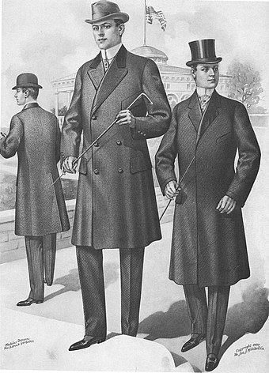

1. Panama Hats- Ryann Becker

They were worn in Panama in the 1600s. These hats became popular from 1900 to 1920 in America due to the construction of the Panama Canal. The workers would wear these hats to protect themselves from the sun. However, these hats were created in Ecuador. The raw material to make these hats is in Ecuador and made from a palm leaf called, "Toquilla Straw". (Textbook page 431, <https://eleganciatropical.com/history-of-panama-hats-toquilla-straw-origins-elegancia-tropical> , <https://www.panamahatmall.com/en/panama-hat-history.html> )